ERFWeb Finance Guide
Nov 5, 2026 · @Jay Bryan
Finance takes over once a report is fully approved: record the original receipts, check doubtful lines, and clear the report for payment.

Before you start
Sign in at the ERFWeb address with your ER System username and password, in Chrome or Edge. The left menu shows Budgets, Finance queue and Signatures under Work queues, plus Summary.
- A report reaches Finance only after its last approval. Drafts and reports still For Approval never appear here.
- Finance never rejects a report on its merits. A doubtful line goes to an Expense Verifier, and a line that fails goes to Level 2 to decide.
- You never process your own report: it shows Your report and its buttons are off.
- Every action is recorded in the audit trail, which Finance can read under Audit.

Step 1: Find reports in the Finance queue
Every fully approved report that is not yet cleared is on the Finance queue page.
- Click Finance queue in the left menu.
- Type in Search employee, purpose or reference no., or pick a Receipts status to narrow the list.
- Turn on Include cleared to see reports already cleared for payment.
- Click a report to open it with its lines, receipts scans and approval timeline.
Each row shows the receipt status and, when it applies, a pill:
Pill | Meaning
Under verification | A line is with an Expense Verifier; clearing waits
Not verified: query Level 2 | A verifier could not confirm a line; you send it to Level 2
Your report | Your own report; another Finance user processes it
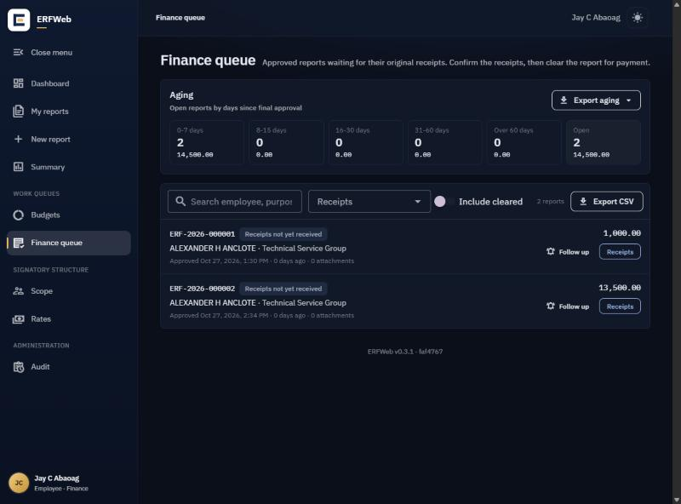

Step 2: Record the original receipts
When the employee hands in the paper receipts, record them on the report's row.
- Click Receipts on the row. The Record receipts window opens.
- Pick the status:
  - Receipts received: all originals are in. This is recorded once and cannot be undone.
  - Receipts incomplete: some are missing. Say which ones under Which receipts are missing? (required).
- Click Save.
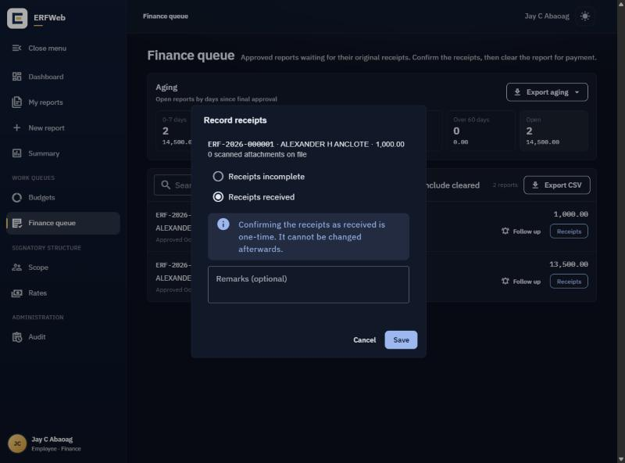
Status | Meaning
Receipts not yet received | Approved; nothing handed in yet
Receipts incomplete | Some originals missing; your remarks say which
Receipts received | All originals in; ready to clear
Cleared for payment | Done; the report leaves the open queue

Step 3: Follow up on missing receipts
While receipts are outstanding, remind the employee by SMS.
- Click Follow up on the row.
- The message is filled in for you: Hi <employee>, Finance has not yet received the original receipts for <ERF no.>. Please submit them to Finance. Thank you. Edit it if needed.
- In the Send SMS window, click Send. The employee and the report's Level 1 and Level 2 signatories are texted.
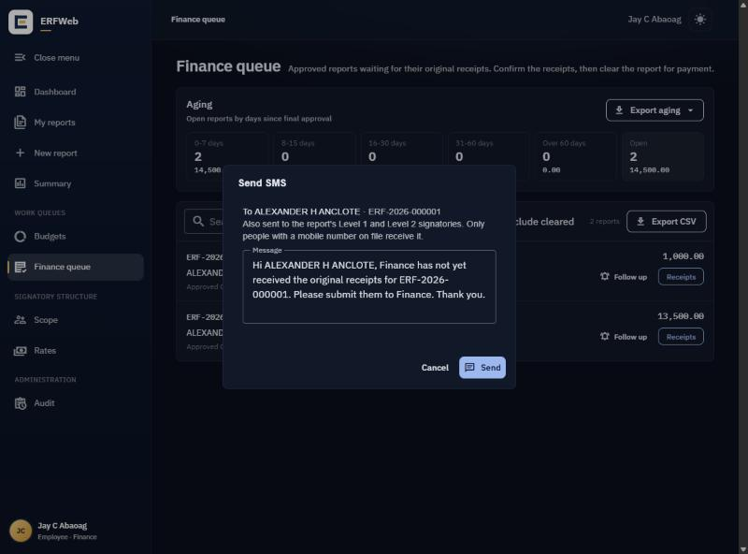
The row then counts the follow-ups and shows when the last one was sent. Sending twice by accident never texts twice.

Step 4: Ask for a line to be verified
If a line looks wrong, send it to the Expense Verifiers instead of rejecting it. You can do this any time before the report is cleared.
- Open the report from the queue.
- On the Verification card, click Verify a line.
- In Ask for a line to be verified, pick the line under Which line? and say What does Finance doubt?
- Click Send to verifiers.
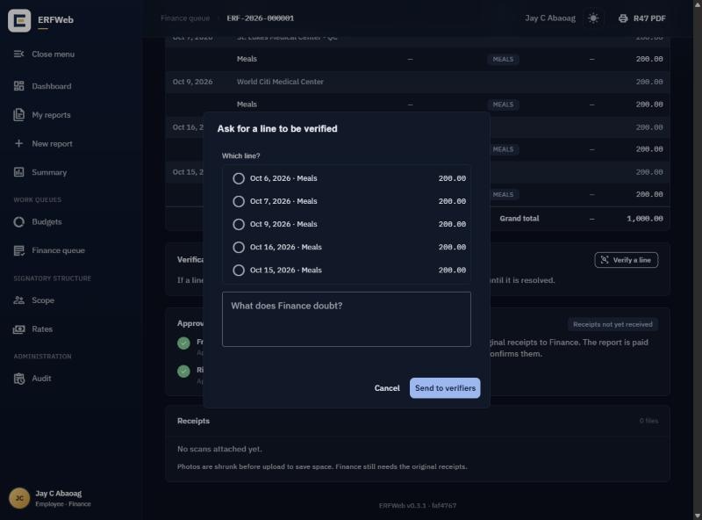
The row now shows Under verification; you can still record receipts, but clearing waits. The verifiers and the employee are notified; your reason is never shown to the employee.
You get a text and an email when the verifier records a finding and when Level 2 decides, as long as your mobile number and email are on file.
When the verifier records a finding:
Finding | What you do
Verified, or Verified with note | Nothing; the request closes and you carry on
Not verified | The row shows Not verified: query Level 2. Open the report, click Query Level 2, say What should Level 2 decide? and click Send query
Level 2 then lets the line through (you carry on), returns the report to the employee (it leaves your queue), or rejects it (final).

Step 5: Clear for payment
A report can be cleared once its receipts are received and no verification is open.
- Click Clear for payment on the row. (While a verification is open, the row says Clear after the verification is resolved instead.)
- In Clear this report for payment?, add Remarks (optional).
- Click Clear for payment.
Clearing is final. The report leaves the open queue; turn on Include cleared to see it again.

Approve signatures
A signature image prints on the R47, with an ELECTRONIC SIGNATURE watermark, only after Finance approves it. The System Administrator loads each signature; you check it here.
- Click Signatures in the left menu. The Waiting for approval tab lists new and replaced signatures.
- Check that the image is the person's signature and is clear.
- Click Approve. The R47 prints it from then on.
- Or click Reject, add a Reason (optional) and click Reject and remove. The image is deleted, and the System Administrator must load a new one.
- Your own signature shows Your own: another Finance user approves it.
- Until a signature is approved, the R47 prints "Electronically approved" with the date and time in its place.
- A replaced signature comes back to Waiting for approval.
- The Approved tab lists approved signatures with who approved them and when.

Aging, summaries, budgets and exports
Where | What it shows | Export
Aging card on the Finance queue | Open reports by days since final approval: 0–7, 8–15, 16–30, 31–60, over 60 | Export aging (CSV or PDF)
Finance queue list | The reports for your current search and filters | Export CSV
Summary | Expenses by expense date for everyone (scope All), by department, approved only or not | CSV or PDF
Budgets | Every cost center's yearly budget, used, remaining and % used; for monitoring only | Export (CSV)
Exports are capped at 10,000 rows and are recorded in the audit trail.

Common problems
What you see | What to do
A report you expect is not in the queue | It is not fully approved yet, or it is cleared: turn on Include cleared
No Clear for payment button | Record Receipts received first
Clear after the verification is resolved | Wait for the verifier's finding; if it is Not verified, query Level 2
Save stays off in Record receipts | For Receipts incomplete, say which receipts are missing
A message that the report changed | Someone else acted on it; the page reloads, check it and try again
Follow up fails | The employee has no mobile number on file; ask the System Administrator
Your report, buttons off | Another Finance user must process your own report
Your own: another Finance user approves it | Another Finance user must approve your own signature
A signature you expect is not under Waiting for approval | It is already approved (see Approved), or the System Administrator has not loaded it yet

